Training Manual

A TEMPLATE FOR RESTAURANTS

Thank you for downloading the Toast Restaurant Training Manual Template!

A restaurant employee training manual provides your staff with the rules, guidelines and clarity they need to do their jobs efficiently. This makes it easier for you to lead and for your staff to succeed in their new position.

No two restaurants are run the exact same way. That’s why you should take your time in developing this training manual to be as clear and specific as possible. Don’t overlook the processes and systems in your restaurant. Make sure all new hires follow this program, no matter how much experience they bring to your restaurant.

Instructions for Your Restaurant Employee Training Manual

Start with the cover page [below]. Insert your company logo as well as your name, address, phone number and email address.

Then, continue to the training manual itself. Remember, each role in your restaurant will need its own training manual.

As you’re filling out each section, there are prompts and directions in blue italics below each section header. Your writing starts in the regular text below the prompts. Simply delete “[Start Here].” and begin writing.

Finally, when you’re ready to show off your handbook, simply delete everything in italics, as well as this first page and the last page. To print, click File > Print.

Ready? Let’s get started!

Official [Position] Training Handbook

Owner’s Name
Address
555-555-5555
email@domain.com

Table of Contents

Below are all the sections of this template. This template is an example of a server training manual. Add or remove subsections as needed. We strongly suggest adding page numbers and pictures as well!

INTRODUCTION
I. Company Overview
II. Guest Service Overview
III. Training Schedule
IV. Disclaimer

SECTION 1: ROLE FUNCTION & RESPONSIBILITIES
I. General Job Guidelines and Responsibilities
II. Personal Appearance and Uniform
III. Role Opening Procedures
IV. Role Closing Procedures
V. Health Procedures
VI. Kitchen Safety and Sanitation

SECTION 2: GUEST SERVICE
I. Guest Service Introduction
II. Types of Guests
III. Guest Service Guidelines

SECTION 3: SERVING A TABLE
I. Setting the Table
II. Greeting and Seating
III. Taking and Placing Drink Orders
IV. Drink Service
V. Taking and Placing Food Orders
VI. Suggestive Selling and Specials
VII. Food Service
VIII. Quality Control
IX. After-Dinner Service
X. Closing Out a Table
XI. The Farewell
XII. Table Bussing and Cleaning
XIII. Asking for Help

SECTION 4: SHIFT CLOSE
I. Shift Close Procedures
II. Comping and Voiding Checks
III. Manager Check-Out

SECTION 5: CONCLUSION & KNOWLEDGE CHECK

Introduction
Company Overview
Use this opportunity to welcome your new hires and get them excited about working for you! Give a brief overview on the history of the company. You may want to write this section from your point of view or as a welcome letter. If this is a franchised location, explain what makes this location so special to work at. Include and define your mission statement in this section. Your employees are a walking representation of your brand, your company and ultimately the front line of defense for your business. Make sure that they know exactly what to say about your restaurant when they’re working the floor or even off the clock. It’s best to start things off on a positive, welcoming note; you’ll have plenty of time for the more official training information!

[Start Here]

GUEST SERVICE OVERVIEW
Give a quick overview of guest service at your restaurant. You’ll explain guest service in detail in a later section but hit some of the key points that you’ll want to serve as the major takeaways. Realistically, most of your hires won’t read every single word of this handbook, so get across the two or three main takeaways about behavior, communication and anything else you deem important. Additionally, because you do want every new hire to read this handbook, include another reminder to please read this handbook in its entirety and come to you with any questions.

[Start Here]

TRAINING SCHEDULE
Include the training schedule for the position in this section. What requirements must the trainee complete before they can start working the position on their own? Explain why following the schedule and completing these requirements is important. Make sure everyone involved understands the repercussions of not meeting expectations and achieving their goals. Will they get an extra day of training? Is there another role with less responsibility that might be a better fit for them? Don’t forget to remind readers to come to you with any questions about this handbook and its contents. Encourage your employees to ask for help as part of your operational processes.

[Start Here]

DISCLAIMER
Your training manual is not a legal contract. Make that clear in this section and that employment is at-will. However, be sure to set clear expectations. It's not uncommon to have new hires and the trainers sign off on an expectations agreement.

[Start Here]

SECTION 1:
Role Function & Responsibilities

Following up on your company overview, state the function and responsibilities associated with this role in your restaurant. Explain why you decided on these and how you expect all employees in your restaurant to follow these when they work.

[Start Here]

GENERAL JOB GUIDELINES AND RESPONSIBILITIES
Give a quick overview of the guidelines and responsibilities associated with this position. First, consider more general guidelines for their role. Should they be in perfect uniform before clocking in? Should they walk carefully in the kitchen? Next, thinking about smaller topics like handling plates, glasses and other items. Are servers required to never handle glass by the rim with their hand, or required to never handle silverware with their hand? What about when they aren’t serving tables? Is there a sidework calendar? A cleaning checklist? These are all things to consider when writing this section.

[Start Here]

PERSONAL APPEARANCE AND UNIFORM
Do you have employee grooming standards? Do you require a uniform or a dress code? Will you be providing this attire, or will employees be asked to purchase this on their own? Are certain outfits required for dinner versus lunch? Private events versus normal shifts? Answer all of these questions clearly. Additionally, if there are different uniform requirements for men and women or for those in different positions, make these clear as well. Here is where you should also address policy on tattoos, hair, grooming, jewelry, makeup, perfume, cologne, etc.

[Start Here]

ROLE OPENING PROCEDURES
Give your new employee an overview of the opening procedures in the server role. Present the opening procedures in whatever format you use in your restaurant: a list, checklist or bullet points. Don’t forget to explain why completing the opening procedures is important. Will it make their shift run more smoothly? Is it a process that is signed off on by a manager?

[Start Here]

ROLE CLOSING PROCEDURES
Give your employee an overview of the closing procedures next. Again, present the closing procedures in whatever format you use in your restaurant. Emphasize the areas of security, such as locking up and securing valuables. Don’t forget to explain why completing the closing procedures is important. Even though some employees may only work opens and some may only work closes, it’s essential everyone understands the process for both.

[Start Here]

HEALTH PROCEDURES
How should staff handle allergy warnings? Do you have a policy for when someone is choking or is having a medical emergency?

[Start Here]

KITCHEN SAFETY & SANITIZATION
Remind employees to follow all guidelines and regulations that ensure safety in the kitchen. This should cover the steps taken to keep employees safe from harm and customers safe from improperly prepared food. Hand washing, glove wearing, food cleaning and dishwashing should all be reviewed.

[Start Here]

SECTION 2:
Guest Service

This section is arguably the most important. Here, you’ll explain everything related to guest service at your restaurant. In this section, reinforce the core values of your restaurant and that every action your employees take - be it in the back of the house or in the front of the house, on premise or off-premise - should reflect those core values. These individuals will serve as the face of your restaurant to everyone who walks through your door, so the details you lay out in this section should not be scarce. Once again, remind new hires to approach you with any and all questions that arise in this section as there will be little room for misunderstanding in the future.

[Start Here]

GUEST SERVICE INTRODUCTION
Here is where your restaurant’s guest service policies should be explained in detail. How do you define guest service at your restaurant? How should staff interact with guests to exemplify this definition? Provide examples of specific behaviors based on your core values. If you operate a casual family grill, chances are your servers can be a bit more relaxed and informal than in one of the city’s finest dining establishments. Use this section to remind readers that they are always representing your brand and should carry themselves with dignity even when they are not directly interacting with guests at a table.

[Start Here]

TYPES OF GUESTS
In this section, explain the types of guests your servers will encounter in your restaurant. How do they make a timid guest feel welcome? How do they accommodate a guest with disabilities? How do they please an aggressive guest?

[Start Here]

GUEST SERVICE GUIDELINES
Here is where you specify guidelines related to the behaviors you explained in the introduction. Are servers required to greet guests within one minute of arrival? Is there a script for greeting guests? Include conflict resolution with difficult guests in this section too. What’s your policy for how employees interact with guests when there is a disagreement or conflict? Is there a service recovery model your staff should follow? Would you prefer employees attempt to resolve problems themselves first, or should they go to their managers with any issues immediately? Best practice is to empower your employees to resolve guest complaints before deferring to a manager.

[Start Here]

SECTION 3:
Serving a Table

Here is the instructional section of your handbook. Employees will read about the proper way to set a table and how to react when someone has a food allergy. When giving these instructions, be as detailed as possible. Since there are some legal ramifications for the health and safety sections, it may be wise to consult an attorney and/or link to official documentation or law from the local and federal government.

SETTING THE TABLE
What goes on the right? The left? Here would be a fitting time to include an image or a photo for employees to reference.

[Start Here]

GREETING AND SEATING
How does a server introduce themselves to a new table? What does a guest receive after they have been sat? Free bread? A drink coaster?

[Start Here]

TAKING AND PLACING DRINK ORDERS
Are drink orders taken by seat numbers? Ensure all IDs are checked before serving alcohol. What are acceptable forms of ID? Also, are those under the age of 21 allowed to handle alcohol in any capacity?

[Start Here]

DRINK SERVICE
How are drinks served to a table? What is your policy on refills?

[Start Here]

TAKING AND PLACING FOOD ORDERS
Are food orders taken by seat numbers? Are appetizer or children’s orders taken first? How are orders taken and then placed into your POS system?

[Start Here]

SUGGESTIVE SELLING AND SPECIALS
What are some tips for successful suggestive selling? Should staff suggest appetizers while guests are studying the menu, or suggest side orders with entrées? When should specials be explained to guests? Why is suggestive selling important to the success of your business?

[Start Here]

FOOD SERVICE
How is food served to a table? When are condiments and necessary silverware brought to the table?

[Start Here]

QUALITY CONTROL
What are things to look for before food leaves the kitchen? How often should servers be checking back with tables after food is served?

[Start Here]

AFTER-DINNER SERVICE
What should be suggested for after-dinner service? Dessert? Drinks?

[Start Here]

CLOSING OUT A TABLE
How should a server present a check to a table? What are the procedures for handling cash and credit cards?

[Start Here]

THE FAREWELL
What does a server say to guests when they are departing?

[Start Here]

TABLE BUSSING AND CLEANING
Who is responsible for bussing and cleaning tables? Where do dirty dishes go? What supplies should they use to clean?

[Start Here]

ASKING FOR HELP
Remind employees to ask for help when needed, especially for menu-specific issues, health or allergy concerns, or even proper pouring methods. To not ask for help could impact the guest’s experience in a negative way.

[Start Here]

SECTION 4:
Shift Close

The moment most people have been waiting for! It’s time to go home, what needs to be completed first? While you gave an overview of closing procedures in a previous section, use this section to highlight the specific shift close procedures related to this position in your restaurant.

SHIFT CLOSE PROCEDURES
What steps must servers complete at the end of their shift? Finishing cleaning tasks or sidework? Handing off current tables to another server? Completing a shift review to close checks, declare tips and tip out? Printing a shift report?

[Start Here]

COMPING AND VOIDING CHECKS
Are employees allowed to comp or void tabs on their own, or do they need approval? If they can do this themselves, how do they go about this on the POS system?

[Start Here]

MANAGER CHECK-OUT
Are employees required to check out with a manager before leaving the restaurant after finishing their shift? If so, what does that check-out process look like?

[Start Here]

SECTION 5
Conclusion

Wrap up your handbook by reminding employees to always act professionally, represent your brand well and to be excited about their new position! Remind them to reach out to a trainer or manager with any questions or concerns. End with a knowledge check to reinforce the information presented in this manual.

[Start Here]

EMPLOYEE SIGNATURE

Employee Name: __________________________

Signature: _______________________________

Date: ___________________________________
Employer Signature: _______________________

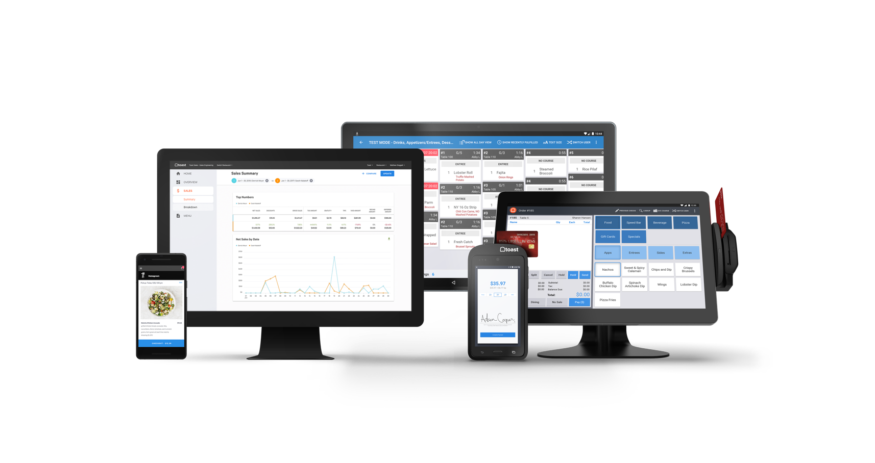
Getting the Most From
Your Restaurant Employees

We hope this template helps you create an awesome employee
handbook for your restaurant. Our goal is for your restaurant to
run as efficiently and profitably as possible, and a well-informed
staff is one of the best ways to accomplish this.

That’s why we’d like to offer you a free demo of Toast POS
and restaurant management system. Its ease of use and rich reporting
functionality make it simple for new hires to start taking orders immediately.
Beneficial for both employees and owners, Toast’s interface has helped
some restaurants increase tips by 3X and boost sales by 20%.

Whether you’re creating this handbook for a new restaurant
or an existing one, Toast is ready to partner with you and
help you maximize the success of your business.

Talk to one of our product specialists and learn how
Toast can help your restaurant achieve success.

Sign up for your demo today and we’ll be in touch!

